Towards a Creative Exploitation of Digitised Knowledge in eLearning Systems

Radoslav Pavlov
Institute of Mathematics and Informatics – Bulgarian Academy of Sciences, Sofia, Bulgaria
radko@cc.bas.bg

Desislava Paneva
Institute of Mathematics and Informatics – Bulgarian Academy of Sciences, Sofia, Bulgaria
dessi@cc.bas.bg

Abstract
A promising direction in the current eLearning strategies and activities points to contemporary ubiquitous learning through the involvement of digital libraries, knowledge grids or different repositories in the learning processes. This article aims to present some functional characteristics and architectures of these contemporary technologies. It investigates and exposes some applications of digital libraries with multimedia content and knowledge grids for eLearning purposes.
Keywords
Digital libraries with multimedia content, digital library architectures, knowledge grids, eLearning grids eLearning systems.

- introduction

Within the last years a wide range of eLearning systems have been brought to market. These systems have become more and more complex and each of them covers a wide range of functionality. Many systems assist the user throughout the entire process of producing and publishing learning material over the web. It is certainly desirable when a system that perfectly matches your needs already exists. But very often such a perfect system would only exist if one could take pieces of existing systems and rearrange them to a new system. Ideally you could even add your own components to this newly generated system.
This means that an eLearning system should be build as a distributed application, deployed on several hosts. These distributed applications would need an underlying infrastructure that allows each of these components to access and share resources or functionality across the Internet. Such problems have already been addressed in the area of scientific distributed computing and lead to the definition of a concept that is often referred to as grid technology.
On the other hand, the huge amounts of digital resources produced by the information society activities may be a rich source of information and digitised knowledge. This knowledge is available in different Internet-based knowledge-delivering structures such as digital libraries and digital repositories.
This article presents the basic concepts of digital libraries with multimedia content and their main characteristics. The article includes three types of digital libraries architectures and describes how they are implemented in two European projects. It formulates some special features and principles that are and have to be met by the digital libraries so that the latter can be used efficiently by the eLearning systems. It investigates and exposes some applications of digital libraries for eLearning purposes. Another innovative decision is that the eLearning system could be built as a distributed application, deployed on several hosts. In this case the base technology is the knowledge grid. The article considers some knowledge grid-driven scenarios and applications in education.

- basic concepts of digital libraries with multimedia content
Digital libraries with multimedia content are a contemporary conceptual solution for access to information archives. According to an informal definition of digital libraries, they are managed collections of information, with associated services, where the information is stored in digital formats and accessible over a network. Digital libraries contain diverse hypertext-organized collections of information (digital objects such as text, images, and media objects) for use by many different users. The collected information is organized thematically and uses hyperlinks that allow the connection between any piece of data and additional data on the same topic. As an addition to the digital objects collection, there are many levels of metadata, indexes, hierarchical links, etc. [1]
The main characteristics of digital libraries are the following:
- Ability to share information;
- New forms and formats for information presentation;
- Easy information update;
- Accessibility from anywhere, at any time;
- Services available for searching, selecting, grouping and presenting digital information, extracted from a number of locations. Using these services depends on the user preferences, needs and wishes of the users, i.e. there is personalization available;
- Contemporary methods and tools for digital information protection and preservation;
- Ability to use different types of computer equipment and software;
- No limitations related to the size of content to be presented.
In the past digital libraries were isolated and monolithic systems limited to access to content of a single provider. The development of the technologies during the last years provides new functionalities and advanced services to contemporary digital libraries such as specialized services for
- Multi-layer and personalized search, context-based search, relevance feedback, etc.
- Resource and collection management;
- Metadata management;
- Indexing;
- Semantic annotation of digital resources and collection etc.
The new digital libraries will provide and manage complex services, processes and workflows on the basis of existing services. It is expected that these services be heterogeneous, autonomous and distributed. The flexibility, the automatic adaptation, the access anywhere and anytime, the decentralization, the wide variety of digital objects and collections, the information security, etc. will be of the some requirements. [10]
Digital library architectures
A hypermedia digital library (HDL) can be considered as a database, storing data of different type (text, raster, vector, static and moving images, animation, audio or other media), which is structured in a way to allow easy manipulation and use. Data is stored in the database in the form of objects, usually annotated to facilitate running search queries. To make these procedures automatic, the HDL includes techniques for descriptive presentation of the data semantics as well as services for its management.
Web technologies help organizing hypermedia digital libraries by providing a means to structure and present them in a hypermedia manner. Hypermedia represents hypertext media; therefore it adheres to the hypertext information organization rules. Users are allowed to quickly move across subject-related topics in a non-linear way. These topics may include sets of objects, such as text, images, audio and other media, which relate to one another via hyperlinks.
The HDL is a simplified conceptual solution for presenting complex multimedia content in the web space.
Grid-based infrastructure - The digital library is currently undergoing a transition from a statically integrated system to a dynamic federation of services. This transition is inspired by new trends in technology which include developments in technologies like web services and grid infrastructures as well as by the success of new paradigms like Peer-to-Peer Networking and Service-oriented Architectures. The transition is driven by digital library "market" needs. This includes a requirement for a better and adaptive tailoring of the content and service offer of a digital library to the needs of the relevant community as well as to the current service and content offer, and a more systematic exploitation of existing resources like information collections, metadata collections, services, and computational resources.
Such new decentralized and service-oriented architectures for digital libraries make the library functionality available in a more cost-effective and tailored way and thus open up new application areas for digital libraries. Future digital libraries should enable any citizen to access human knowledge any time and anywhere, in a friendly, multi-modal, efficient, and effective way. A core requirement for such digital libraries is a common infrastructure which is highly scalable, customizable and adaptive.
A grid is a network or collection of distributed computer resources, which are accessible through local or global networks and are presented to the end user via an enormous virtual computer system, i.e. it is a virtual, dynamically changing organization of structured resources, which are shared among individuals, institutions and systems. Some of the main advantages of the grid technology are: optimized and personalized access and enhanced management of digital resources; virtual resource organization; ability to be used worldwide, etc. The grid technology introduces essential improvements in the current distributed information systems, which are the proper basis for building contemporary digital libraries.
In essence, the creation of virtual digital libraries on the basis of grid-based infrastructures, support for the integration of metadata, personalization services, semantic annotation and the on-demand availability of information collections and extraction services will make digital libraries more useful and attractive to a wider clientele. Such a test-bed digital library infrastructure has been created for the DILIGENT project (integrated project funded in part by the European Commission FP6 IST Programme), based on the grid technology [14]. Figure 1 depicts DILIGENT infrastructure.
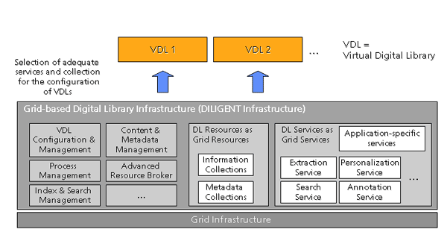
Figure 1: Grid-based digital library Infrastructure
Hyperdatabase infrastructure - Future digital libraries should enable any citizen to access human knowledge any time and anywhere, in a friendly, multi-modal, efficient, and effective way. A core requirement for such digital libraries is a common infrastructure which is highly scalable, customizable and adaptive. Ideally, the infrastructure combines concepts and techniques from peer-to-peer data management, grid computing middleware, and service-oriented architectures. That infrastructure is offered in the project DELOS „A Network of Excellence on Digital Libraries” [12] funded by the EU's Sixth Framework Programme [13]. Peer-to-peer networks allow for loosely coupled integration of digital library services and the sharing of information such as recommendations and annotations. Grid computing middleware supports the dynamic allocation and deployment of complex and computationally intensive digital library services such as the extraction of features from multimedia documents to support content-based similarity search. A service-oriented architecture provides common mechanisms to describe the semantics and usage of digital library services. Furthermore, it supports mechanisms to combine services into workflow processes for sophisticated search and maintenance of dependencies. As depicted in Figure 2, the digital library architecture envisaged consists of a grid of peers which provide various kinds of digital library services such as storage, extraction or retrieval services. These digital library services can be combined with processes. High scalability is achieved by executing the processes in a completely distributed, peer-to-peer fashion. For that, metadata about processes, services, and load of the peers is distributed and replicated over the grid. This is performed by a small hyperdatabase layer atop each peer. This layer also takes care of peer-to-peer navigation and execution of processes.
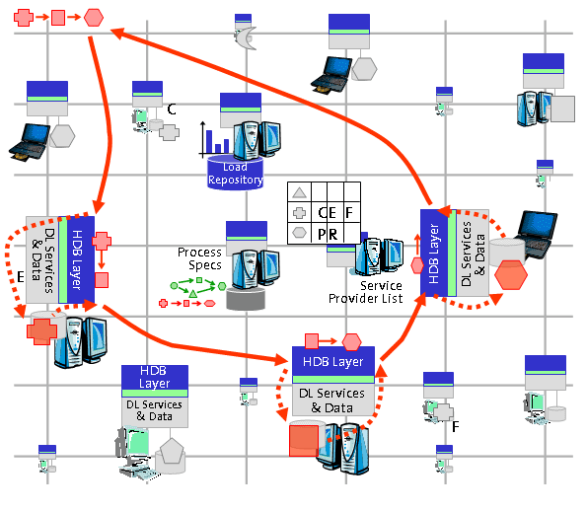
Figure 2: Digital library architecture based on a hyperdatabase infrastructure
- digital libraries and elearning systems vis-a-vis
The involvement of digital libraries in the eLearning processes requires the formulation of special features and principles that are to be met by the digital libraries so that the latter can be used efficiently by the eLearning systems. The last-years’ trends of eLearning for optimising and advancement put additional requirements to the learning process and construction of work scenarios. In that sense, the following special features and principles can be laid down:
Resources-on-demand - Digital libraries have to provide resources and materials on-demand to the end-user. Tools and technologies to support indexing, cataloguing, retrieving, aggregating, and creatively exploiting of different textual, non-textual and complex objects /resources have to be developed in them. New eLearning trends dictate the implementation of tools for personalised preference-based access to digital libraries in which the user’s preferences will be used for filtering, extraction and aggregation of digital objects in order to reduce the volume of data presented to the user.
Resource description - The objects in digital libraries have to be segmented (i.e. partitioned into logical units), annotated and semantically indexed so that metadata are attached to them and describe their content including semantic descriptions based on appropriate domain ontologies. The metadata are written with standard description languages and are stored in an appropriate metadata repository that provides management services including efficient retrieval based on Boolean and similarity queries so that it is possible to search for content satisfying various search parameters.
Interoperability - Establish protocols, standards and formats to facilitate the use and assembly of distributed digital libraries and their resources.
Intellectual property rights - A key element for digital libraries is appropriate recognition and protection of legal rights such as copyright, publicity, privacy, matters of obscenity, defamation, intellectual property protection. The vision for digital libraries includes fluid, easy access to a wide variety of materials. This is often in conflict with the duties of libraries and archives entrusted with care and management of materials that may be subject to privacy rights or other needs for security. Efforts to formulate digital libraries will be delayed or frustrated in the absence of a common, responsible framework of rights, permissions, and restrictions that acknowledges the mutual needs of rights-holders and users of materials in digital libraries. The challenge here is, in part, to develop mechanisms, perhaps social expectations independently or in combination with technical means, regarding acceptable levels of access (for example where privacy rights are at issue) and use (such as the extent or permissible copying and dissemination).
Heterogeneous resources in a coherent way - A digital library that provides diverse content will be characterized by heterogeneity in original format, in digital format and resolution, and in the level of detail and format of descriptive information that is available to support access. In the face of great diversity of content and description, special problems attend to the development of a coherent approach to indexing and presenting retrieval results. It is important that any approach allows all the information available to be used to aid the retrieval rather than force the user who wants to search across the entire resource to rely on some lowest common denominator of descriptive information.
Sustaining the resource - The creation and maintenance of digital libraries is very expensive. Costs are incurred for production, for ongoing provision of access, and for preservation of the digital information. The cost to develop and operate a distributed architecture for long-term archiving, migration, and backup of digital materials are high, too. Libraries would benefit from better estimate of costs and trends in cost for production and maintenance of a corpus of digital information i.e. it is important to develop economic models for the support of digital libraries.
Provide more efficient and more flexible tools for transforming digital content to suit the needs of end-users - Today, each content item in most digital libraries is represented in multiple forms or versions. The multiple forms exist to serve varieties of users, function as archival masters, and reduce download time and transmission loads on networks. A content provider may produce large and small versions of images; compressed and uncompressed versions of images, texts, audio, and video; texts formatted for browser software and also formatted for preservation or publication; and materials both in proprietary formats and in public or "open" formats. This burden of plural production and maintenance results from the fact that today many digital objects are hard to transform on the fly. Similar capabilities are also needed to ensure the preserving of digital content for posterity.
The objects in digital libraries and repositories are usually stored in raw format and the content often in not structured to be used for learning purposes. For that reason, it is important to provide clear-defined processes of transformation of library’s resources into learning objects. One decision is offered in the project “Knowledge-on-Demand for Ubiquitous Learning” (LOGOS) through the development of authoring studio for generation of learning resources from existing digital archives. The authoring studio will include a working environment with tools for pre-processing of digital audio and video objects from existing archives. The pre-processing tasks may include format transformation, segmentation, indexing, annotation, semantic description, etc. The authoring studio will permit building-up of reusable and compound learning objects. The versatile pre-processing of the available audio and video materials will allow the users - authors of learning materials, lecturers and/or advanced learners - to achieve a good personalisation level of the produced courseware, considering the learning context, learners aims, stimuli, and interests, educational and cultural background, learning places, learning styles, course organisation, course duration, etc. The creation of the courseware will be based on sound educational model of the learning process, considering the specifics of combined (web-based, DVB-based, mobile) delivery mode. The web-based versions of courseware, produced by means of the authoring studio, will be formed according to international learning standards (e.g. SCORM) in order to be applicable for different Learning Management Systems.

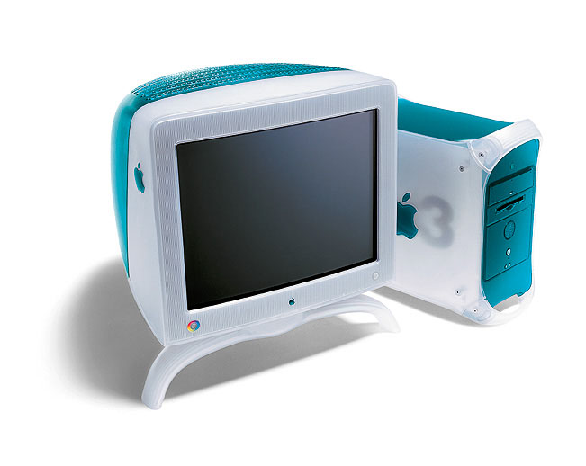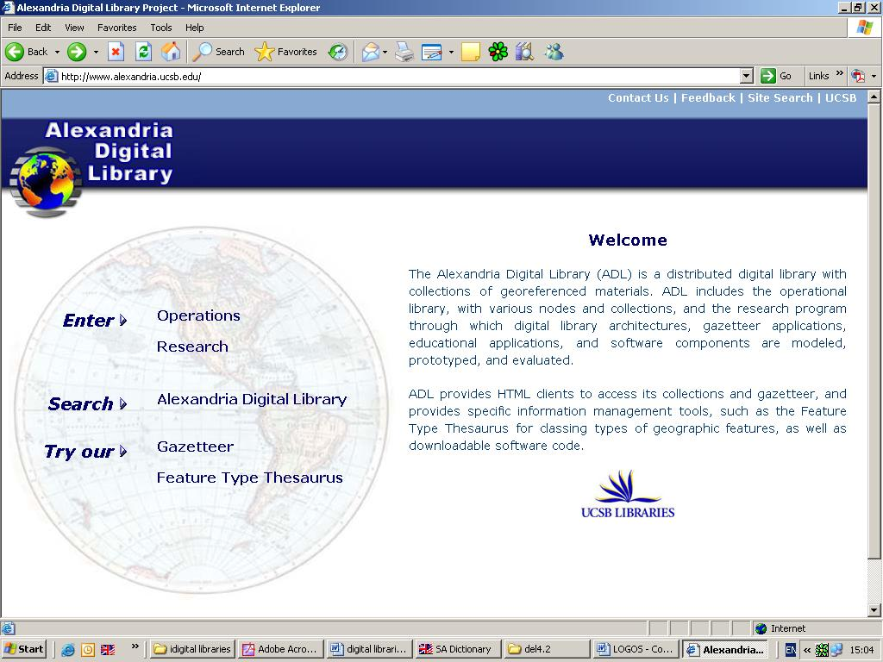
Digital library
Data
Digital objects
Repository of learning materials
End Users
- Learning providers;
-Authors of learning materials
- Tutors;
- Lecturers, etc.

Pre-processing, conversion, annotation
Digital objects
Search and Request
Search and Request
Virtual Learning Environment
Semantic-oriented indexing

Annotation

Searching

Aggregating

Retrieving, etc.
Deliver learning content
Figure 3: Digital library in the eLearning process

- Some applications of digital libraries in elearning systems
During the last few years a lot of eLearning projects have been developed using the digital libraries with multimedia content as a source of digital objects. This section presents some of them.
The project “DialogPlus - Digital Libraries in Support of Innovative Approaches to Teaching and Learning in Geography” aims to embed a wealth of existing digital resources developed in the US and the UK into the curricula of four US and UK higher education institutions, in four different sub-areas of Geography. The electronic resources are made available through interoperable digital library technology and integrated directly into course units in undergraduate programs supported by Virtual Learning Environments within each institution. [5]
The project “Digital Libraries for Global Distributed Innovative Design, Education and Teamwork” (DIDET) proposes the development, implementation and use of a test-bed to improve the teaching and learning of students partaking in global team-based design projects and combines the use of digital libraries with virtual design studios. [9]
The Arts and Humanities Data Service (AHDS) Visual Arts [3] through its association with the Arts and Humanities Research Board serves the research initiatives by:
- Providing Internet access to collections of visual arts digital resources created by and of use to the research community;
- Preserving visual arts digital resources to ensure its long term use;
- Promoting good practice and advice for the creation and use of visual arts digital resources for research purposes.
Moreover, AHDS Visual Arts has completed “Promoting the use of on-line image collections in learning and teaching in the visual arts” (PICTIVA), a two-year project whose aim is to promote the use of online image collections in learning and teaching in the visual arts. [4]
The project “Knowledge-on-Demand for Ubiquitous Learning” (LOGOS) contributes to the openness for ubiquitous learning of the large-scale repositories of digitised text, graphics, audio, video objects and to the process of their transformation into learning content, adequately enhancing and facilitating the knowledge building. The project addresses innovative development of the main components of the learning processes – resources, services, communication spaces. New functionality of the learning communication spaces will be achieved by integrated web-, digital television and mobile technologies, supporting cross-media learning content. New eLearning management systems based on this integration will improve and extend the learning services within new consistent pedagogical scenarios. The use of annotated and adequately structured knowledge from digital archives will enable lecturers/authors to participate in ‘open source’ content development from massive, dynamically growing learning resources.
The project is targeted at the following results: 1/ Development of learning scenarios for ubiquitous learning in different learning contexts, modelling learning process and learning materials by considering different ways and phases of cross-media authoring, access, delivery, study and assessments through different modes and levels of integrated web-based, DVB and mobile technologies; 2/ Development of authoring studio for generation of learning resources from existing digital archives; 3/ Development and implementation of knowledge-on-demand ubiquitous learning platform, integrating learning resources and communication spaces through knowledge-on-demand learning services; 4/ Extended experimentation of the functionality and usability of the platform implementation by authors/lecturers and learners in multiple national contexts. The project meets the challenges of Europe enlargement by its research and development to provide highly customizable knowledge-on-demand learning services for the broad public in ubiquitous manner.

- from digital libraries to knowledge grids elearning applications
Traditionally, grid computing has addressed the needs of long-running scientific computations submitted as batch jobs. Long-running batch jobs can be distributed across several nodes in a grid and executed in parallel, resulting in shorter execution times. The benefits of grid computing extend to the provision of resource virtualization already supported by developing standards of the Open Grid Services Architecture (OGSA). Their use can shift the boundary of traditional networked models out to dynamically include and exclude elements of other organizations, thus increasing management and economical complexity.
In the case of networked business models, and thus from a virtual organization point of view, traditional technologies such as virtual private networks and Intranets/Extranets based on HTTP provide just an infrastructure for their basic functionality.
Conceptually, the grid can be thought of in terms of three layers: the computational/data grid, the information grid and the knowledge grid (Figure 4).

Computational/Data grid
Knowledge grid
(Semantic grid)
Information grid

Data to Knowledge
Control
Process models (Meta models)
Processes
Transactions

Figure 4: Three layer grid abstraction

The bottom layer is the computational and data grid: the computer hardware and data networks upon which the work will be conducted. Above this lies the 'information grid': the databases of information to be accessed by the hardware, and systems for data manipulation. On top lies the 'knowledge grid', where high-level applications mine the data for the knowledge that can form the basis of semantic understanding and intelligent decision-making.
A data/computational grid forms the fabric of the grid to provide raw computing power, high-speed bandwidth and associated data storage in a secure and auditable way.
A knowledge grid uses knowledge based methodologies and technologies for responding to high-level questions and finding the appropriate processes to deliver answers in the required form. This last layer includes data mining, machine learning, simulations, ontologies, intelligent portals, workflow reasoning and Problem Solving Environments for supporting the way knowledge is acquired, used, retrieved, published and maintained. A knowledge grid should provide intelligent guidance for decision makers and hypothesis generation.

Knowledge grid-driven applications in education

The utilisation of currently available communication and information technologies has turned traditional location based education into location independent ones. Nowadays, learning is equivalent to searching for sources and selecting the appropriate source to study from. The multitude of sources available on the Internet makes the selection of the appropriate source a rather difficult task. Learners need to access large volumes of data, most times distributed in many locations. Learners also need a variety of services available on demand that can be used and accessed from their environment to satisfy their learning needs. All of the above can be enabled by the utilisation of grid technologies.
Numerous possible scenarios for utilisation of knowledge grid in the eLearning procedure are realisable. Most generally speaking they can be summarized by the following scenario:
Some users need to access certain digital objects to satisfy their learning needs. They connect to the learning provider portal to request the materials. The portal is connected to the knowledge grid that provides access to large volumes of digitised knowledge, most likely distributed at many locations. Special services find the relevant materials across the grid and deliver to the learning provider and by him to the users in suitable form.
One hypothetical scenario, assuming the use of knowledge grid, is the following: a learner on an early Sunday morning is watching a documentary on television. The topic of the documentary is the solar planet system and the learner finds this quite interesting, so she desires to learn some more. A little later, while travelling on the back seat of her parents’ car during a typical Sunday journey, she uses her palmtop to connect to her school’s portal to use the grid infrastructure and from there to NASA database to view some photos. These photos are actually located in a number of storage devises and in various physical locations, but the student views them as a unified collection available on the grid. After viewing some photos of Mars (and perhaps after viewing Mars through a telescope connected to the grid), she decides to create a simulation of the relative positions of Mars and Earth in our solar system. So she demands the appropriate service for this on the grid and starts the simulation. While the student is watching the simulation on her palmtop, the computers from a number of school laboratories (closed on Sundays) – all connected to the grid – share their CPU power to allow her to create all the data required for this service. [2]
This is just one possible scenario that illustrates the utilization of grid technologies in the everyday learning procedure.
The following three projects explore the knowledge grid technology, its main opportunities and advantages (the paradigm of service-orientation, ubiquity, user-centricity, distributed resources, etc.) and propose different conceptual decisions for their implementation in eLearning.
ELeGI (European Learning Grid Infrastructure) is an EU-funded Integrated Project that aims at facilitating the emergence of a European grid infrastructure for eLearning and stimulating research of technologies to enhance and promote effective human learning. [6]
ELeGI promotes and supports a learning paradigm shift focused on knowledge construction using experientials based and collaborative learning approaches in a contextualized, personalized and ubiquitous way. This new paradigm is based on a learner centred approach: learning is student-centred and seen as personal and active construction of his/her own knowledge. Considering people at the centre, learning is clearly a social, constructive phenomenon. It occurs as a side effect of realistic simulations, interactions, conversations, collaborations, and enhanced presence in dynamic virtual communities. [6]
The philosophy and approach behind grid technologies show the right characteristics for achieving an effective learning. Indeed, they allow access to and integrate the different technologies, resources and contents that are required in order to realise the new paradigm. They are the most promising approach to realise an infrastructure that will allow learning process actors to collaborate, to take part in realistic simulations, to use and share high quality learning data and to innovate solutions of learning and training. Grid will be able to support learning processes allowing each learner to use, in a transparent and collaborative manner, the resources already existing online, by facilitating and managing dynamic conversations with other human and artificial actors available on the grid. [6]
The ELeGI project has three main goals:
- to define new models of human learning enabling ubiquitous and collaborative learning, merging experiential, personalised and contextualised approaches;
- to define and implement an advanced service-oriented grid based software architecture for learning. This will allow us to access and integrate different technologies, resources and contents that are needed in order to realise the new paradigm. This objective will be driven by the pedagogical needs and by the requirements provided by the test-beds (SEES) and informed by the experience gained through implementing the demonstrators;
- to validate and evaluate the software architecture and the didactical approaches through the use of SEES and demonstrators. The project will build extensively on advanced work already done, creating new learning environments rather than creating new learning resources. [6]
Akogrimo (Access to Knowledge through the Grid in a mobile World) is a project funded by the European Commission under the FP6-IST programme. The project runs from July 2004 until June 2007. The project team comprises 14 European organisations. The idea behind the Akogrimo framework is to deal with situations where mobile dynamic virtual organizations (MDVO) should dynamically adapt the organisational structure to changing local situations, dynamically establish and process complex workflows, and access data and compute intensive services from distributed/mobile resources. The following features are exhibited:
- mobility and context awareness;
- personalisation, privacy, security;
- cross-organisational distributed resources;
- heterogeneous, dynamic environments;
- Quality of Service (QoS);
- job and data services. [8]
Potential deployment scenarios are e.g.:
- eLearning, considering learners, resources, and teachers, featuring collaboration, personalisation (learning profiles, special needs), learner-centricity, context-awareness, ubiquity/accessibility/availability, nomadism/mobility;
- e-health, for patients, doctors, resources, etc.; requiring resource sharing (by virtualization of distributed resources), access policies, continual accessibility, high performance computing (e.g. real-time image composition);
- disaster/crisis handling, requesting ad-hoc establishment of MDVOs for multi-organisational collaboration and resource sharing, complex problem and data domains, rapid changes and decisions, etc. [8]
The project SeLeNe: Self eLearning Networks (IST-2001-39045) is a one-year Accompanying Measure funded by EU FP5 running from 1st November 2002 to 31st October 2003, extended until 31st January 2004. The SeLeNe project uses eLearning as a test-bed application to explore novel ways of bridging the gap between semantic web technology and peer-to-peer computing in a knowledge grid environment. A Self eLearning Network can be defined as a distributed repository of educational metadata describing learning objects available on the web, collaboratively built and used by anyone who wishes to use existing learning objects (LOs) or to construct new learning objects, in any knowledge domain. [7]
Disciplines (knowledge domains) usually employ ontologies to structure information relative to their field of study. Essentially, knowledge grids provide concept spaces for discovering relevant information, and thus serve as an information discovery support layer. In a knowledge grid, information resources are discovered by mapping domain-specific concepts (from ontology) to the attributes (in metadata) used to describe the information resources.
Knowledge grids can benefit significantly from semantic web technology, which offers standard languages (for example, W3C Resource Description Framework (RDF)) for describing the semantics of various kinds of information resources. [7]
SeLeNe aims to support knowledge grids, by bringing together ontologies, RDF, and peer-to-peer technology in order to develop some of the urgently needed techniques for managing distributed, evolving metadata repositories, for flexible semantic reconciliation of metadata, and for personalisation of the view of grid knowledge and information resources in order to match individual users’ needs.
Furthermore, SeLeNe can be considered as addition to the traditional LMS because of the following considerations:
- Presentation of content - LMS act as delivery systems for the presentation of learning content to learners. In contrast, SeLeNe is an ‘intelligent catalog’ allowing the registration of learning objects (LOs) and the discovery of useful LOs via their associated metadata;
- Assessment and tracking - LMS perform administrative functions such as tracking the progress and attainment of students. SeLeNe has no knowledge of this kind. It may be used to discover LOs that can be used for assessment, but their validation is beyond the scope of SeLeNe;
- Communication and collaboration - LMS often have tools that allow asynchronous communication based on email within a group of users (e.g. an instructor and his class). SeLeNe goes beyond this in its ‘reactive’ functionality that will allow automatic notification of events and changes in LO descriptions;
- Search - LMS may allow search across LOs at a single site, usually searching for keywords within the LO content itself. SeLeNe allows searching of LOs at many distributed sites, via their descriptions rather than their content;
- Personalisation - Personalisation in LMS tends to be concerned with remembering which courses the user is allowed to view, and how they like their pages to be presented. In contrast, SeLeNe provides a wide range of personalisation techniques based on profiles, views and trails. [7]

- Conclusion
The presented paper does not intend to make a comprehensive analysis of the topic. Rather, we trace several possible ways for creative exploitation of digitised knowledge in eLearning systems based on programme documents of the EU and European research projects.

References

- D. Krastev (2005). Central Library of Bulgarian Academy of Sciences – present and future, The libraries of Bulgarian Academy of Sciences, Reference book, Bulgaria
- Michalis Xenos, Bill Vassiliandis, Athanassios Skodras, GRID Technologies => 'Education' = 'Distance Education', In proceeding: 1st International ELeGI Conference on Advanced Technology for Enhanced Learning, Italy, 2005.
- Arts and Humanities Data Service (AHDS) Visual Arts, Available online: http://vads.ahds.ac.uk/index.html
- PICTIVA project, Available online: http://vads.ahds.ac.uk/learning/pictiva/index.html
- DialogPlus project, Available online: http://www.dialogplus.org/
- ELeGI (European Learning Grid Infrastructure), Available online: www.elegi.org
- SeLeNe project: Self e-Learning Networks, Available online: http://www.dcs.bbk.ac.uk/selene/
- Akogrimo project, Available online: http://www.mobilegrids.org/
- DIDET project, Available online: http://dmem1.ds.strath.ac.uk/didet/
- K. Kiernan, A. Kekhtyar (2003). EPT: Edition Production Technology for Multimedia Contents in Digital Libraries, Presented on Workshop on Multimedia Contents in Digital Libraries, USA
- Project DILIGENT “Digital Library Infrastructure on Grid Enable Technology” - http://www.diligentproject.org/
- Project DELOS „A Network of Excellence on Digital Libraries” - http://www.delos.info/
- EU's Sixth Framework Programme - http://fp6.cordis.lu/fp6/home.cfm
- Project DILIGENT: Digital Library Infrastructure on Grid Enable Technology - http://www.diligentproject.org/

